**Semester one examination, 2023**

**Question/Answer Booklet**

**HUMAN BIOLOGY**

**UNIT 3**

Name: Marking Key

Teacher: ______________________________________________________

**Time allowed for this paper**

Reading time before commencing work: ten minutes

Working time for the paper: three hours

**Materials required/recommended for this paper**

***To be provided by the supervisor***

This Question/Answer Booklet

Multiple-choice Answer Sheet

***To be provided by the candidate***

Standard items: pens (blue/black preferred), pencils (including coloured), sharpener, correction fluid/tape, eraser, ruler, highlighters

Special items: up to three calculators, which do not have the capacity to create or store programmes or text, are permitted in this ATAR course examination

**Important note to candidates**

No other items may be taken into the examination room. It is **your** responsibility to ensure that you do not have any unauthorised material. If you have any unauthorised material with you, hand it to the supervisor **before** reading any further.

**Structure of this paper**

|  |  |  |  |  |  |
| --- | --- | --- | --- | --- | --- |
| Section | Number of questions available | Number of questions to be answered | Suggested working time (minutes) | Marks available | Percentage of examination |
| Section One Multiple-choice | 30 | 30 | 40 | 30 | 30 |
| Section Two Short answer | 6 | 6 | 90 | 101 | 50 |
| Section Three Extended answer  Part A | 2 | 1 | 50 | 20 | 10 |
| Part B | 2 | 1 | 20 | 10 |
|  |  |  |  | **Total** | 100 |

**Instructions to candidates**

1. The rules for the conduct of the Western Australian examinations are detailed in the *Year 12 Information Handbook 2022: Part II Examinations*. Sitting this examination implies that you agree to abide by these rules.

2. Write your answers in this Question/Answer booklet preferably using a blue/black pen. Do not use erasable or gel pens.

3. Answer the questions according to the following instructions.

Section One: Answer all questions on the separate Multiple-choice answer sheet provided. For each question, shade the box to indicate your answer. Use only a blue or black pen to shade the boxes. Do not use erasable or gel pens. If you make a mistake, place a cross through that square, then shade your new answer. Do not erase or use correction fluid/tape. Marks will not be deducted for incorrect answers. No marks will be given if more than one answer is completed for any question.

Section Two: Write your answers in this Question/Answer booklet. Wherever possible, confine your answers to the line spaces provided.

Section Three: Consists of two parts each with two questions. You must answer one question from each part. Tick the box next to the question you are answering. Write your answers in this Question/Answer booklet

4. You must be careful to confine your answers to the specific questions asked and to follow any instructions that are specific to a particular question.

5. Supplementary pages for planning/continuing your answers to questions are provided at the end of this Question/Answer booklet. If you use these pages to continue an answer, indicate at the original answer where the answer is continued, i.e. give the page number.

**Section One: Multiple–choice 30% (30 Marks)**

This section has **30** questions. Answer **all** questions on the separate Multiple-choice answer sheet provided. For each question, shade the box to indicate your answer. Use only a blue or black pen to shade the boxes. Do not use erasable of gel pens. If you make a mistake, place a cross through that square, then shade your new answer. Do not erase or use correction fluid/tape. Marks will not be deducted for incorrect answers. No marks will be given if more than one answer is completed for any question.

Suggested working time: 40 minutes.

1. The process of re-programming pluripotent stem cells to differentiate into neurons in order to treat neurodegenerative diseases is best known as

(a) gene therapy.

(b) somatic gene therapy.

(c) cell replacement therapy.

(d) germline therapy.

Questions 2 – 4 refer to the following information:

Evangeline was cooking chicken nuggets for her family and as she pulled them out of the oven her 4-year-old brother Paul went to grab one from the hot oven tray. Paul quickly pulled his hand away, and then cried out in pain.

2. Which of the following receptors would be stimulated to cause the response Paul demonstrated after touching the oven tray?

(a) touch receptors

(b) pain receptors

(c) thermoreceptors

(d) chemoreceptors

3. Which of the following most correctly identifies the effector in the response?

(a) The skeletal muscles in his arm.

(b) The motor neurons that stimulated his muscles.

(c) The sensory neurons that sent the information to his central nervous system.

(d) The primary motor area of his cerebral cortex.

4. Which of the following best describes why Paul cried out in pain **after** he pulled his hand away?

(a) He was in shock due to the extremely high temperature of the oven tray.

(b) He is only little so his brain is not fully developed.

(c) The neural pathway in the reflex arc blocks the motor pathway to the cerebrum.

(d) The information was passed directly from sensory to motor neuron in the spinal cord.

Question 5 and 6 refer to the diagram below showing the action of a hormone at a target cell.

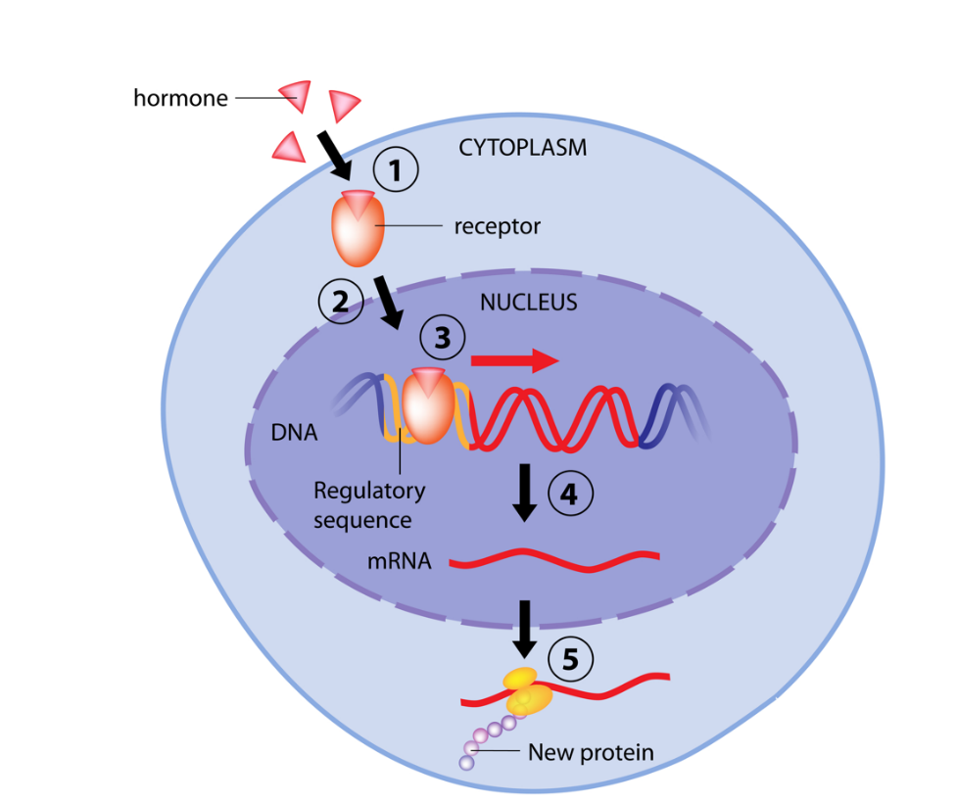

5. The type of hormone involved in this mode of action is most correctly known as a

(a) lipid-soluble, steroid hormone.

(b) water-soluble, steroid hormone.

(c) lipid soluble, protein hormone.

(d) water-soluble, protein hormone.

6. The type of response carried out by this type of hormone will generally be

(a) faster, and short-lasting.

(b) slower, and short-lasting.

(c) faster, and long-lasting.

(d) slower, and long-lasting.

7. Damage to the pineal gland may result in

(a) an underactive thyroid gland.

(b) difficulty sleeping.

(c) a higher osmotic pressure in the body fluids.

(d) type 1 diabetes mellitus.

8. An increase in parathormone levels in the blood could lead to a/an

(a) increase in calcium in the blood, and an increase in calcium in the bones.

(b) decrease in calcium in the blood, and a decrease in calcium in the bones.

(c) increase in calcium in the blood, and a decrease in calcium in the bones.

(d) decrease in calcium in the blood, and an increase in calcium in the bones.

Question 9 – 11 refer to the diagram below showing the structure of the brain.

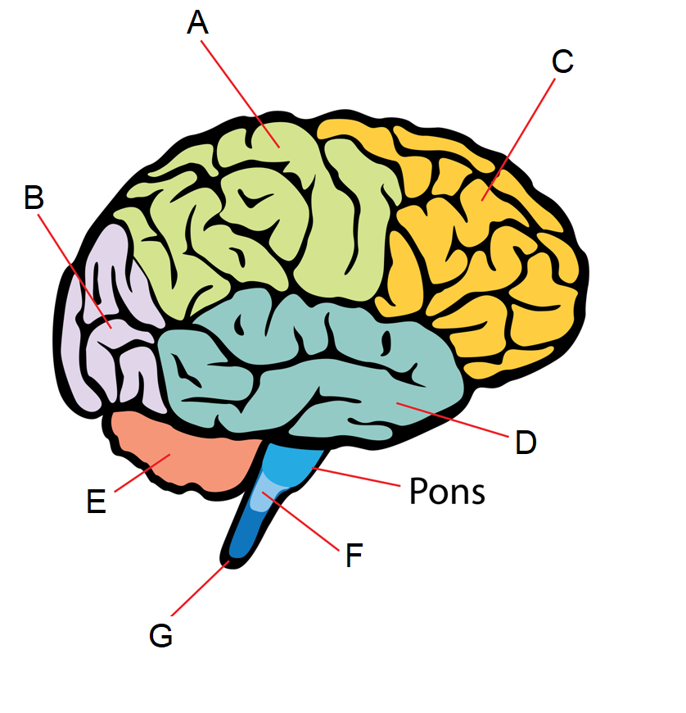

9. The lobe of the cerebral cortex labelled A is known as the

(a) frontal lobe.

(b) temporal lobe.

(c) parietal lobe.

(d) occipital lobe.

10. Changes to breathing rate and depth would most likely be a result of action from which of the following labelled parts?

(a) D

(b) E

(c) F

(d) G

11. Damage to the part labelled E could lead to which of the following symptoms?

(a) jerky movements

(b) difficulty breathing

(c) excessive sweating

(d) paralysis

Question 12 – 14 refer to the following table of data collected by a group of Year 11 General Human Biology students after conducting an experiment testing the effect of types of exercise on heart rate.

|  |  |  |  |
| --- | --- | --- | --- |
| **Type of Exercise** | **Heart rate (bpm)** | | |
| Trial 1 | Trial 2 | Trial 3 |
| Running | 120 | 127 | 130 |
| Walking | 80 | 85 | 88 |
| Skipping | 140 | 138 | 150 |

12. The mean heart rate over the three trials for walking is approximately

(a) 194 bpm

(b) 84 bpm

(c) 85 bpm

(d) 88 bpm

13. Which of the following graphs would be most appropriate to construct when displaying the mean heart rate for each exercise?

(a) column graph

(b) line graph

(c) histogram

(d) scatter plot

14. Which of the following would most likely increase the reliability of the experiment conducted by the Year 11 students?

(a) Allowing for rest breaks between each trial of exercise.

(b) Increasing the number of trials or the number of students tested.

(c) Making sure the stopwatch being used is calibrated correctly.

(d) Only doing the experiment on females.

15. What is the name given to the sticky substance found in the ears which is part of the external defence mechanisms?

(a) mucus

(b) sebum

(c) lysozyme

(d) cerumen

16. Some fundamentalist religious groups are opposed to the use of vaccines to assist in developing immunity. This decision to not participate in vaccination programs is most likely due to

(a) cultural reasons.

(b) ethical reasons.

(c) misinformation.

(d) economic reasons.

17. The type of immunity provided by an antibody serum is

(a) natural, active immunity.

(b) natural, passive immunity.

(c) artificial, active immunity.

(d) artificial, passive immunity.

18. Amalee went out for a fancy buffet dinner at Crown for her birthday. After returning home later that night she started complaining of pains in her stomach and diarrhoea. Her doctor suspected infection from a bacterium known as *Clostridium perfringens.*

The most likely mode of transmission for this infection is

(a) disease specific vector.

(b) direct contact.

(c) ingestion of contaminated food.

(d) transfer of body fluids.

19. A mosquito bite can become red, swollen and itchy. The swelling can be best explained by which of the following?

(a) T-lymphocytes stimulated the B-cells to release histamine and heparin.

(b) Mast cells were stimulated to release cytokines and heparin.

(c) B-cells released antibodies which migrated to the infected area.

(d) Mast cells released histamine which increase permeability of blood vessels in the area

20. Radioactive iodine can be used as a treatment for which of the following conditions?

(a) hyperthyroidism

(b) hypothyroidism

(c) hyperglycaemia

(d) hyperparathyroidism

Questions 21 – 23 refer to the following diagram illustrating the cell-mediated immune response.

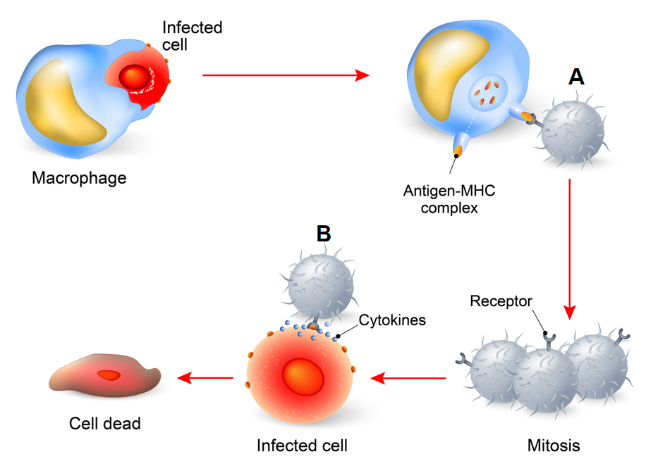

21. The cell labelled A is most likely a

(a) killer T-cell.

(b) suppressor T-cell.

(c) helper T-cell.

(d) plasma cell.

22. The cell labelled B is most likely a

(a) killer T-cell.

(b) suppressor T-cell.

(c) helper T-cell.

(d) plasma cell.

23. Which of the following cells is not produced during the cell-mediated immune response?

(a) killer T-cells

(b) suppressor T-cells

(c) helper T-cells

(d) plasma cells

24. Which layer of the meninges can be described as a delicate layer containing blood vessels that sticks close to the surface of the brain and spinal cord?

(a) arachnoid mater

(b) pia mater

(c) dura mater

(d) upper mater

25. The part of the brain that connects the left and right hemispheres is known as the

(a) cerebellum.

(b) corpus callosum.

(c) amygdala.

(d) hypothalamus.

26. Which of the following is not considered a role of luteinising hormone?

(a) Stimulate production of testosterone.

(b) Stimulate release of egg during ovulation.

(c) Stimulate production of sperm.

(d) Stimulate production of corpus luteum.

27. Before some operations, patients can be asked to refrain from eating or drinking several hours before the surgery. Which of the following hormones would **not** be likely to be at a higher concentration during the fasting periods before surgery?

(a) antidiuretic hormone

(b) glucagon

(c) cortisol

(d) insulin

28. A bundle of nerve fibres in the peripheral nervous system is known as a/an

(a) nerve

(b) tract

(c) axon

(d) neurilemma

29. Which of the following types of neurons is found in the eye, ear and nose?

(a) unipolar, sensory neurons

(b) bipolar, sensory neurons

(c) multipolar, sensory neurons

(d) pseudounipolar, sensory neurons

30. An increase in adrenocorticotropic hormone would lead to an increase in

(a) antidiuretic hormone.

(b) adrenaline.

(c) noradrenaline.

(d) aldosterone.

**End of Section One**

**Section Two: Short answer 50% (101 Marks)**

This section has **six** questions. Answer **all** questions. Write your answers in the spaces provided.

Supplementary pages for planning/continuing your answers to questions are provided at the end of this Question/Answer booklet. If you use these pages to continue an answer, indicate at the original answer where the answer is continued, i.e. give the page number.

Suggested working time: 90 minutes.

**Question 31 (20 marks)**

The diagram below shows the hypothalamus and pituitary.

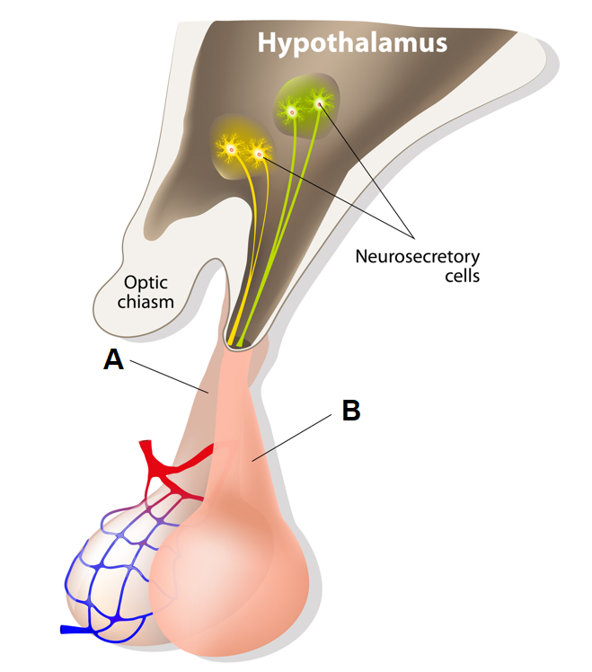

(a) Complete the table below by identifying each lobe of the pituitary (labelled A and B in the diagram), and **two** hormones released by each lobe. (6 marks)

|  |  |
| --- | --- |
| **Description** | **Marks** |
| |  |  |  | | --- | --- | --- | |  | **A** | **B** | | **Name of lobe** | anterior | posterior | | **Hormones** | **Any two from:**  FSH/LH/GH/ACTH/prolactin/TSH | Oxytocin  ADH | | 1–6 |
| **Total** | **6** |

(b) The neurosecretory cells in the diagram extend into lobe B, describe the role of these cells in controlling the production and release of hormones from this lobe. (3 marks)

|  |  |
| --- | --- |
| **Description** | **Marks** |
| To produce the hormones/to produce oxytocin and ADH | 1 |
| Send hormones to posterior lobe/B (for storage) | 1 |
| To send nerve impulse to trigger release of hormones | 1 |
| **Total** | **3** |

The lobe of the pituitary labelled A releases some hormones that can control other endocrine organs throughout the body, such as the gonads.

(c) Describe **one** function of each hormone released from the female gonads. (2 marks)

|  |  |
| --- | --- |
| **Description** | **Marks** |
| (oestrogen promotes) development of secondary sexual characteristics/regulation of menstrual cycle/other specific function | 1 |
| (progesterone promotes) maintenance of endometrium/regulation of menstrual cycle/development of mammary glands for milk secretion | 1 |
| **Total** | **2** |

(d) Explain how the hypothalamus works to control the release of hormones from the male gonads through the action of the lobe labelled A. (4 marks)

|  |  |
| --- | --- |
| **Description** | **Marks** |
| Sends releasing factors/gonadotropin releasing factors to anterior pituitary/A | 1 |
| Through vascular network/blood capillaries/blood stream | 1 |
| Causes (production and) release of luteinising hormone/LH from anterior pituitary | 1 |
| LHt ravels through blood to testes to stimulate release of hormones/testosterone | 1 |
| **Total** | **4** |

**Question 31** (continued)

(e) Some hormones, including human growth hormone (hGH) released by the pituitary gland, can be produced through recombinant DNA technology. Describe how this process works to create synthetic hGH. (5 marks)

|  |  |
| --- | --- |
| **Description** | **Marks** |
| Any five of | |
| * Gene that codes for hGH is cut out/isolated with restriction enzyme * Same enzyme used to cut plasmid (isolated from bacterium) * DNA ligase joins adjacent nucleotides/sugar-phosphate backbone of hGH gene and plasmid * Plasmid placed back into bacterium and bacteria reproduces/multiplies * Bacteria produces hGH using code from gene for hGH * Protein hormone/hGH is extracted/purified (therefore have synthetic version of hormone) | 1–5 |
| **Total** | **5** |

**This page has been left blank intentionally**

**Question 32 (14 marks)**

Type 1 diabetes mellitus is a condition characterised by a deficiency in the protein hormone insulin, released from the pancreas. Untreated, this condition leads to hyperglycaemia and symptoms such as increased appetite and fatigue.

(a) Describe the mode of action for a protein hormone such as insulin. (5 marks)

|  |  |
| --- | --- |
| **Description** | **Marks** |
| Attaches to receptor on cell membrane (of target cell) | 1 |
| Forming a hormone-receptor complex | 1 |
| Activates secondary messenger inside cell | 1 |
| (secondary messenger) activates/changes action of enzymes | 1 |
| This changes the rate of reaction in the cell | 1 |
| **Total** | **5** |

(b) Explain why type 1 diabetes leads to hyperglycaemia. (3 marks)

|  |  |
| --- | --- |
| **Description** | **Marks** |
| Hyperglycaemia refers to a higher than normal blood glucose level | 1 |
| Insulin works to lower blood glucose levels | 1 |
| A deficiency in insulin means glucose does not enter cells/is not stored as glycogen (therefore remaining in blood = hyperglycaemia) | 1 |
| **Total** | **3** |

(c) Explain the symptoms of increased appetite and fatigue in someone suffering from type 1 diabetes. (3 marks)

|  |  |
| --- | --- |
| **Description** | **Marks** |
| Cells are not receiving glucose leads to reduced cellular respiration | 1 |
| This leads to reduced energy released by cells = fatigue | 1 |
| Cells being ‘starved’ of energy source = increased appetite | 1 |
| **Total** | **3** |

(d) One potential treatment of type 1 diabetes is gene therapy. Explain how this would work to treat the condition. (3 marks)

|  |  |
| --- | --- |
| **Description** | **Marks** |
| Works to replace missing/faulty insulin gene with healthy/functioning gene that codes for insulin | 1 |
| Introduced to the cells via vector/viral vector/other means | 1 |
| The patient’s own cells can now create insulin (therefore no longer deficient in insulin) | 1 |
| **Total** | **3** |

**Question 33 (12 marks)**

Lyme disease is a bacterial borne disease that is transmitted to humans by a bite from an infected tick.

(a) Identify the mode of transmission for the bacteria that causes Lyme disease. (1 mark)

|  |  |
| --- | --- |
| **Description** | **Marks** |
| Vector/disease-specific vector | 1 |
| **Total** | **1** |

(b) State **three** structural features of a bacterium. (3 marks)

|  |  |
| --- | --- |
| **Description** | **Marks** |
| Any three from | |
| * Slime layer * Unicellular * Lack a nucleus/DNA floats free in cytoplasm * Contains plasmids * Cell wall | 1–3 |
| **Total** | **3** |

Lyme disease, caught early, is usually treatable through a course of broad spectrum, bacteriostatic antibiotics such as amoxicillin.

(c) Describe what is meant by broad spectrum, bacteriostatic antibiotics. (2 marks)

|  |  |
| --- | --- |
| **Description** | **Marks** |
| Broad spectrum – effect a wide range of bacteria | 1 |
| Bacteriostatic – stop bacteria from reproducing | 1 |
| **Total** | **2** |

If left untreated, Lyme disease could potentially lead to peripheral nerve dysfunction due to damage around the spinal cord. This can result in a loss of sensation in some areas of the body. The diagram below shows the structure of the spinal cord.

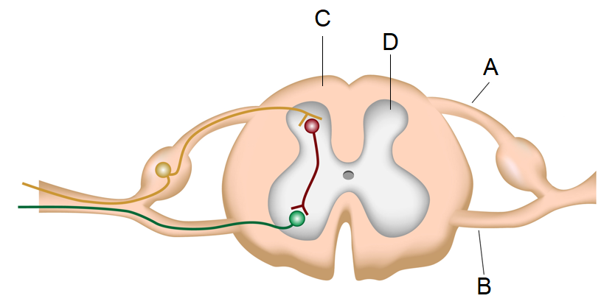



(d) Name and contrast the structure of the sections labelled C and D in the diagram.

(3 marks)

|  |  |
| --- | --- |
| **Description** | **Marks** |
| C – white matter | 1 |
| D – grey matter | 1 |
| Grey matter contains cell bodies and unmyelinated fibres, white matter contains myelinated fibres | 1 |
| **Total** | **3** |

(e) Identify which part in the diagram, A or B, would be damaged if someone had a loss of sensation. Explain your answer. (3 marks)

|  |  |
| --- | --- |
| **Description** | **Marks** |
| A | 1 |
| It contains sensory neurons | 1 |
| Message cannot be transmitted to brain (from spinal cord) so cerebrum does not receive sensory information | 1 |
| **Total** | **3** |

**Question 34 (25 marks)**

An investigation to determine the effect of thyroxine (T4) on core body temperature was carried out on mice. Twenty mice were split into two groups of ten, one group was given periodic injections of T4 over 12 days, while the other group acted as a control.

The internal temperature of each mouse was taken every two days over a 12 day period. The average core temperature for each group over the time period is shown in the table below.

|  |  |  |
| --- | --- | --- |
| **Table 1.** Average core temperature for mice with and without T4 injections over 12 days | | |
|  | Average core temperature (°C) | |
| Days | Group One (given injections of T4) | Group Two (control group) |
| 0 | 37.2 | 37.0 |
| 2 | 37.2 | 37.1 |
| 4 | 37.6 | 36.8 |
| 6 | 38.0 | 37.2 |
| 8 | 38.2 | 37.4 |
| 10 | 38.6 | 37.5 |
| 12 | 39.0 | 37.4 |

(a) Identify the dependent variable in this investigation. (1 mark)

|  |  |
| --- | --- |
| **Description** | **Marks** |
| Core temperature | 1 |
| **Total** | **1** |

(b) Explain the role of the control group. (2 marks)

|  |  |
| --- | --- |
| **Description** | **Marks** |
| To act as a comparison | 1 |
| To see the effects of the T4/thyroxine injection on the other group/experimental group | 1 |
| **Total** | **2** |

(c) Suggest **two** controlled variables for this experiment. (2 marks)

|  |  |
| --- | --- |
| **Description** | **Marks** |
| Any two from | |
| * Same external temperature/environmental temperature controlled * Temperature taken around the same time * Same amount of T4/thyroxine injected in experimental group * Others…. | 1–2 |
| **Total** | **2** |

(d) Construct a graph of the data on the grid below. (5 marks)

|  |  |
| --- | --- |
| **Description** | **Marks** |
| Appropriate title | 1 |
| Both axes labelled with units | 1 |
| Correct scale on both axes  (**note:** y-axis in graph below **incorrectly** shows the y-axis scale without the lines to indicate it is a broken axis. Was unable to find a way to do this in Excel, apologies) | 1 |
| Key | 1 |
| Correctly plotted line graph | 1 |
|  | |
| **Total** | **5** |

(e) Explain the trend shown in this data using scientific reasoning. (4 marks)

|  |  |
| --- | --- |
| **Description** | **Marks** |
| T4/thyroxine increases metabolic rate | 1 |
| Increase in chemical reactions leads to an increase in heat produced/released | 1 |
| Therefore the core temperature of mice with injections increased over time | 1 |
| While the mice without injections maintained a relatively steady core temperature | 1 |
| **Total** | **4** |

**Question 34** (continued)

The findings from this investigation could be used as important data to help further understand the condition known as hyperthyroidism, which can be displayed through symptoms such as excessive sweating and intolerance to heat.

(f) Describe what is meant by hyperthyroidism and suggest **one** possible cause of this condition in humans (2 marks)

|  |  |
| --- | --- |
| **Description** | **Marks** |
| Overactive thyroid gland/overproduction of thyroid hormones/thyroxine | 1 |
| Graves disease/pituitary problems/overproduction of TSH/other reasonable cause | 1 |
| **Total** | **2** |

(g) Explain how hyperthyroidism could lead to excessive sweating. (4 marks)

|  |  |
| --- | --- |
| **Description** | **Marks** |
| Increased thyroxine = increased metabolism | 1 |
| This increases heat produced/released by cells | 1 |
| Increase in temperature detected by (internal) thermoreceptors in hypothalamus | 1 |
| Hypothalamus sends message to sweat glands to release sweat in response to the higher internal temperature | 1 |
| **Total** | **4** |

(h) Explain how excessive sweating could lead to the initiation of the thirst reflex, and describe this homeostatic response. (5 marks)

|  |  |
| --- | --- |
| **Description** | **Marks** |
| Loss of water through sweat increases osmotic pressure of blood/body fluids | 1 |
| Osmoreceptors stimulated/detect increased osmotic pressure | 1 |
| Thirst centre in hypothalamus stimulated | 1 |
| Cerebral cortex has conscious feeling of thirst therefore drink water | 1 |
| Ingestion of water leads to absorption of water into blood which lowers osmotic pressure | 1 |
| **Total** | **5** |

**Question 35 (15 marks)**

The speed of the nerve impulse along myelinated nerve fibres averages around 80 – 120 m/s, whereas the average speed along unmyelinated fibres ranges from 0.5 – 2.0 m/s.

(a) Name the cells of the peripheral nervous system that form the myelin sheath. (1 mark)

|  |  |
| --- | --- |
| **Description** | **Marks** |
| Schwann cells | 1 |
| **Total** | **1** |

(b) Describe how an action potential is generated along a nerve fibre. (5 marks)

|  |  |
| --- | --- |
| **Description** | **Marks** |
| Membrane is at a resting membrane potential of – 70 mV when a stimulus is received | 1 |
| If reaches threshold/ of – 55 mV/a change of +15 mV then voltage-gated channels open | 1 |
| Sodium floods in to cause depolarisation/inside to become positive | 1 |
| )sodium channels close) and potassium channels open and potassium exits the cell | 1 |
| This causes repolarisation/the inside of cell becomes negative | 1 |
| **Total** | **5** |

(c) Explain why the speed of propagation of an action potential is faster along a myelinated fibre. (3 marks)

|  |  |
| --- | --- |
| **Description** | **Marks** |
| Ions cannot enter/exit cell at myelin sheath | 1 |
| Action potentials generated at each node of ranvier | 1 |
| Leads to action potential jumping from node to node/saltatory conduction (which is faster) | 1 |
| **Total** | **3** |

Guillain-Barre syndrome is an autoimmune condition that leads to the destruction of the cells that form myelin in the peripheral nervous system. Symptoms can range from skeletal muscle weakness to damage to the autonomic nervous system, affecting heart rate and kidney function.

(d) Name the affected subdivision of the PNS that could have led to skeletal muscle weakness and contrast this subdivision with the autonomic nervous system. (4 marks)

|  |  |
| --- | --- |
| **Description** | **Marks** |
| Somatic (efferent) | 1 |
| Any three of following contrasting points | |
| * Somatic has no synapse/ganglion, autonomic does **or** somatic has single neuron, autonomic has more than one * Somatic usually voluntary, autonomic usually involuntary * Somatic always excitation, autonomic excitation of inhibition * Somatic has one neurotransmitter, autonomic has two * Somatic targets skeletal muscle, autonomic targets heart/cardiac muscle/smooth/involuntary muscles/glands | 1–3 |
| **Total** | **4** |

(e) The speed of an impulse, even along unmyelinated fibres, is much faster than the speed at which hormones travel in the bloodstream. Outline **two** other differences between the endocrine and nervous system. (2 marks)

|  |  |
| --- | --- |
| **Description** | **Marks** |
| Any two from | |
| * NS is usually local and specific, ES can be more general/widespread * NS is brief/short-lived, ES can be longer-lasting * NS is electro-chemical, ES involves chemicals/hormones * Others… | 1–2 |
| **Total** | **2** |

**Question 36 (15 marks)**

In certain areas of the world, including some mountainous regions of Canada, a job known as an ‘avalanche forecaster’ exists. The role requires skills in mountaineering, knowledge of mountain conditions and dealing with extreme cold weather.

In Quebec, where the Laurentian mountain range exists, the average high temperature in January is around – 8 °C and the low temperature is around – 18 °C.

(a) Calculate the percentage decrease from the average high to low in January in Quebec.

(3 marks)

|  |  |
| --- | --- |
| **Description** | **Marks** |
| Working could vary: | |
| -18 - -8 = -10 | 1 |
| -10/-8 = 1.25 x 100 | 1 |
| 125% decrease in temperature | 1 |
| **Total** | **3** |

(b) Identify the area of the central nervous system that would be involved in regulating the internal temperature of someone working in these extreme conditions. (1 mark)

|  |  |
| --- | --- |
| **Description** | **Marks** |
| hypothalamus | 1 |
| **Total** | **1** |

(c) Describe **two** physiological responses initiated by the nervous system in response to the cold external temperature experienced in Quebec. (4 marks)

|  |  |
| --- | --- |
| **Description** | **Marks** |
| Sympathetic nerves target skin arterioles | 1 |
| Decrease in diameter/vasoconstriction occurs | 1 |
| Nervous impulse targets skeletal muscles | 1 |
| Rhythmic contractions/shivering occurs | 1 |
| **Total** | **4** |

(d) Identify and explain **one** behavioural response of someone working as an avalanche forecaster in extremely cold conditions. (2 marks)

|  |  |
| --- | --- |
| **Description** | **Marks** |
| Any reasonable response, with explanation, for example: | |
| Put on more layers of clothing | 1 |
| Increases insulation and therefore less heat is lost through radiation/conduction/convection | 1 |
| **Total** | **2** |

When working outdoors, the job of an avalanche forecaster could involve a lot of risk, leading to the body to undergo a ‘fight or flight’ response.

(e) State the subdivision of the peripheral nervous system that would be stimulated during the fight or flight response. (1 mark)

|  |  |
| --- | --- |
| **Description** | **Marks** |
| Sympathetic | 1 |
| **Total** | **1** |

The diagram below shows the cross-section of an endocrine organ that could also be stimulated during the fight or flight response.

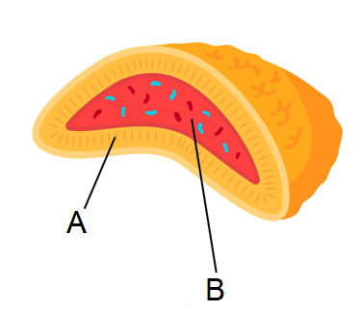

(g) Identify and name the area of the gland above (either A or B) that would be stimulated in the fight or flight response. (2 marks)

|  |  |
| --- | --- |
| **Description** | **Marks** |
| B | 1 |
| Adrenal medulla | 1 |
| **Total** | **2** |

(f) Describe and explain the importance of **one** physiological response initiated by the fight or flight response. (2 marks)

|  |  |
| --- | --- |
| **Description** | **Marks** |
| Any reasonable response, with explanation, for example: | |
| Increased heart rate | 1 |
| allows greater supply of blood to skeletal muscles to increase supply of glucose for respiration | 1 |
| **Total** | **2** |

**End of Section Two**

**Section Three: Extended answer 20% (40 Marks)**

**Part A**

**Question 37 (20 marks)**

Rabies is a preventable disease caused by a viral infection that ultimately affects the central nervous system and can lead to death. It is transmitted through saliva, usually from a bite from an infected animal.

(a) Describe the general structure of a virus and explain how a virus can cause disease.

(7 marks)

|  |  |
| --- | --- |
| **Description** | **Marks** |
| General structure of virus: | |
| Contain DNA or RNA | 1 |
| Surrounded by a protein coat | 1 |
| And (sometimes) a lipid envelope/external lipid membrane | 1 |
| **Subtotal** | **3** |
| How a virus causes disease: | |
| Infect a living cell with its DNA/RNA | 1 |
| Use cells resources to manufacture more virus particles | 1 |
| Virus particles leave cell to infect other cells | 1 |
| This damages/changes/kills the cell = disease | 1 |
| **Subtotal** | **4** |
| **Total** | **7** |

(b) A bite from an animal breaks the skin, an important external defence mechanism. Identify and describe the features of the skin that allow it to protect against infection by pathogens.

(6 marks)

|  |  |
| --- | --- |
| **Description** | **Marks** |
| Any three of the following (1 mark for identifying and 1 mark for describing): | |
| * An impervious barrier/a physical barrier * Prevents entry of pathogens | 1–6 |
| * Releases sweat * Contains salts and acids that prevent growth of pathogens/contains lysozyme an enzyme that destroys bacteria |
| * Sebum/oil from oil glands * Contains substances that kill some bacteria |
| * Unharmful/non-pathogenic bacteria live on the skin * Prevents pathogens from becoming established/reproducing on the skin |
| **Total** | **8** |

The rabies virus is thought to work by attaching to acetylcholine receptors at a neuromuscular junction or synapse.

(c) Describe how transmission of a nerve impulse normally occurs across a neuromuscular junction or synapse. (7 marks)

|  |  |
| --- | --- |
| **Description** | **Marks** |
| Any seven points from the following: | |
| * Action potential reaches axon terminal/pre-synaptic knob * Voltage-gated calcium channels open due to depolarisation * Calcium enters/floods into axon terminal/presynaptic membrane * Causes vesicles with neurotransmitters to migrate to pre-synaptic membrane * Vesicles fuse with membrane and release neurotransmitters/exocytosis of neurotransmitters occurs * Neurotransmitters diffuse across the synapse/gap * They bind to post-synaptic receptors * Causes ligand-gated sodium channels to open * Sodium floods into post-synaptic membrane/next neuron/muscle cell * Causing depolarisation/action potential in the next cell | 1–7 |
| **Total** | **7** |

**Question 38 (20 marks)**

A current, popular method of weight loss is the concept of fasting, or intermittent fasting. This means that a person chooses to go certain periods of time without consuming any food.

(a) Explain why fasting could lead to weight loss. (4 marks)

|  |  |
| --- | --- |
| **Description** | **Marks** |
| Less glucose in the blood due to fasting | 1 |
| Less glucose for cellular respiration in the cells | 1 |
| Leads to using fats as a source of energy in respiration | 1 |
| Breaking down stored fats = weight loss | 1 |
| **Total** | **4** |

(b) Describe and explain the role of the pancreas in maintaining blood glucose levels during periods of fasting. (6 marks)

|  |  |
| --- | --- |
| **Description** | **Marks** |
| Chemoreceptors in alpha cells (in pancreas) detect low levels of glucose in blood due to fasting | 1 |
| Causes release of glucagon | 1 |
| Glucagon causes an increase in blood glucose levels | 1 |
| Stimulates glycogenolysis in the liver/conversion of glycogen to glucose in the liver | 1 |
| Stimulates lipolysis in the liver/breakdown of lipids in the liver | 1 |
| Stimulates production of new glucose from fats and amino acids in the liver/stimulates gluconeogenesis in the liver | 1 |
| **Total** | **6** |

Changes in blood glucose levels can also be caused by secretions from the adrenal cortex and adrenal medulla.

(c) Describe how each part of the adrenal gland is stimulated to release hormones and outline the role of each in blood glucose regulation. (10 marks)

|  |  |
| --- | --- |
| **Description** | **Marks** |
| Adrenal cortex | |
| ACTH releasing factor secreted from hypothalamus | 1 |
| ACTH (produced and) released from anterior pituitary | 1 |
| Travels to adrenal cortex to stimulate release of cortisol/glucocorticoids | 1 |
| Glucocorticoids/cortisol increase blood glucose levels | 1 |
| By causing glycogenolysis/breakdown of glycogen to glucose | 1 |
| And gluconeogenesis/synthesis of glucose from amino acids | 1 |
| **Subtotal** | **6** |
| Adrenal medulla: | |
| Nerve impulse through sympathetic nerves | 1 |
| Causes release of noradrenaline/adrenaline | 1 |
| Causes glycogenolysis | 1 |
| And gluconeogenesis/synthesis of glucose from lactic acid | 1 |
| **Subtotal** | **4** |
| **Total** | **10** |

**Part B**

**Question 39 (20 marks)**

Amy recently took her son Xander to get his 4-year-old immunisations as per the Australian vaccination schedule. These included the diphtheria and tetanus toxoid vaccines as well as the inactivated polio and whooping cough vaccines.

(a) Distinguish between toxoid and inactivated vaccines. (4 marks)

|  |  |
| --- | --- |
| **Description** | **Marks** |
| Toxoid: | |
| Contains the inactivated toxin from a bacterium | 1 |
| Does not contain the entire pathogen/is a subunit/part of pathogen) | 1 |
| **Subtotal** | **2** |
| Inactivated: | |
| Contains a dead/inactivated microorganism | 1 |
| The entire pathogen is used to illicit an immune response/the whole agent is used | 1 |
| **Subtotal** | **2** |
| **Total** | **4** |

(b) Explain how the vaccines could stimulate the antibody-mediated immune response and lead to active immunity. Include a description of the steps of the immune response in your answer. (10 marks)

|  |  |
| --- | --- |
| **Description** | **Marks** |
| Macrophage/dendritic cell consumes antigen from vaccine | 1 |
| Becomes antigen presenting cell/APC | 1 |
| Stimulates a helper T-cell with specific antigen | 1 |
| Cytokines released from helper T-cell/B-cells sensitised and enlarged | 1 |
| Divide by mitosis and produce clone | 1 |
| Plasma cells are created from clone/most of clone become plasma cells | 1 |
| Plasma cells make antibodies (that can attach to antigen) | 1 |
| Memory cells are also created | 1 |
| Spread to body tissues and are long-lasting cells | 1 |
| Can respond to antigen if presented with in future for faster/greater response | 1 |
| **Total** | **10** |

Poor little Xander felt quite unwell 1–2 days after his injections, after taking his temperature Amy noticed it was above the normal tolerance limit for internal body temperature.

(c) Explain how the vaccines could have led to the onset of fever. (6 marks)

|  |  |
| --- | --- |
| **Description** | **Marks** |
| Any six points from the following: | |
| * Pyrogens released by white blood cells * Macrophages/dendritic cells release interleukin-1 * Pyrogens target hypothalamus * Hypothalamus resets body thermostat to higher than normal level * Causes shivering to increase heat production * And vasoconstriction to reduce heat loss * Both of these work to bring internal body temperature up to new level based on thermostat(above normal) | 1–6 |
| **Total** | **6** |

**Question 40 (20 marks)**

Receptors are located throughout the human body, responsible for detecting changes in the internal or external environment. During exercise a number of different receptors can be stimulated.

(a) Name and describe the role of the receptors stimulated in response to changes in gas concentrations during exercise and describe the homeostatic mechanism that will take place as a result of these changes. (12 marks)

|  |  |
| --- | --- |
| **Description** | **Marks** |
| Name and describe receptors: | |
| Chemoreceptors | 1 |
| In the aorta and carotid arteries/aortic and carotid bodies | 1 |
| In the medulla oblongata | 1 |
| Detect increase in CO2 levels/decrease in pH | 1 |
| **Subtotal** | **4** |
| Homeostatic mechanism: | |
| Increase CO2/lower pH during exercise (due to increased cellular respiration) | 1 |
| Cause stimulation of respiratory centre in medulla oblongata | 1 |
| Sends nerve impulse through phrenic nerve to diaphragm | 1 |
| Intercostal nerves to intercostal muscles | 1 |
| Muscles increase rate of contraction | 1 |
| Increase breathing rate and depth during exercise | 1 |
| This increases pH of blood/reduces CO2 levels | 1 |
| This is negative feedback in response to changes detected by receptors | 1 |
| **Subtotal** | **8** |
| **Total** | **12** |

(b) Identify and describe the function of **two** other receptors that may be stimulated during exercise. Explain why these receptors may be stimulated. (8 marks)

|  |  |
| --- | --- |
| **Description** | **Marks** |
| Osmoregulation: | |
| Osmoreceptors stimulated | 1 |
| Detect changes in osmotic pressure/solute concentration | 1 |
| Due to sweating through exercise there would be loss in water/salts | 1 |
| This would cause increase in osmotic pressure and stimulate osmoreceptors | 1 |
| **Subtotal** | **4** |
| Thermoregulation: | |
| Thermoreceptors | 1 |
| Detect changes in internal/external temperatures | 1 |
| Due to increased metabolism/respiration during exercise there would be increase in heat production | 1 |
| Internal body temperature increase would be detected by central thermoreceptors | 1 |
| **Subtotal** | **4** |
| **Total** | **8** |

**End of questions**

**ACKNOWLEDGEMENTS**

**Question 5 – 6** Adapted from: Alila07 (n.d) [hormones action diagram]. Retrieved from

<https://www.dreamstime.com/stock-photos-steroid-hormones-action-image26879893>

**Question 9 – 11** Adapted from: Nn555 (n.d.) [Brain sections diagram]. Retrieved from <https://www.dreamstime.com/royalty-free-stock-photography-brain-sections-image26689077>

**Question 21 – 23** Adapted from: Designua (n.d.) [cell-mediated immunity diagram]. Retrieved from <https://www.dreamstime.com/stock-illustration-cell-mediated-immunity-t-lymphocytes-do-not-secrete-antibodies-response-incorporates-activated-macrophages-natural-killer-image70530277>

**Question 31** Adapted from: Designua (n.d.) [Hypothalamus and pituitary gland diagram]. Retrieved from <https://www.dreamstime.com/stock-image-hypothalamus-pituitary-gland-connected-to-via-stalk-infundibulum-consists-two-lobes-anterior-image40242341#_>

**Question 33** Adapted from: Alila07 (n.d.) [Cross section of spinal cord diagram]. Retrieved from <https://www.dreamstime.com/royalty-free-stock-photos-cross-section-spinal-cord-image18987278>

**Question 36** Adapted from: Masia8 (n.d.) [Kidney and cross section of adrenal gland in flat style]. Retrieved from <https://www.dreamstime.com/kidney-cross-section-adrenal-gland-flat-style-including-vector-diagram-medical-illustration-endocrine-organs-image130645561>